Big Data Engineer II

By Christan Versteeg, 500859503

Contents

1. Summary/Abstract 2

2. Introduction 2

3. Background 2

4. Methods 3

4.1. Data Collection 3

4.2. Data Preparation 4

4.3. Sentiment Analysis Implementation 4

5. Results 4

6. Conclusion and Recommendations 4

7. Bibliography 5

# Summary/Abstract

This document reports on a sentiment analysis project that evaluates hotel reviews using three different methods: the rule-based VADER and TextBlob models, and a supervised Naive Bayes classifier. We discuss the theoretical underpinnings of these models, describe our data collection and preparation methodology, detail the training process of the Naive Bayes classifier, and analyze its performance. We conclude with a discussion of the results and provide recommendations for future work.

# Introduction

The document outlines the execution and results of a sentiment analysis task performed on hotel reviews. Sentiment analysis is an invaluable tool in understanding customer sentiment and can inform business decisions and strategies. This analysis is particularly pertinent to the hospitality industry, where customer satisfaction is paramount.

# Background

First I started of by tackling what NoSQL program I would use. I decided to use MongoDB since it is suggested in the assignment, plus it has a clean UI called MongoDB Compass. I downloaded it on the website. (MongoDB, 2024)

I then created a Database and a collection for it, and imported the hotel reviews csv:

It imported roughly half a million entries:

After importing the csv into mongo I wanted to access it in the Python script, which I did like so:

Which I did at the hand of PyMongo and Pandas documentation (MongoDB, 2024) (Pandas, 2023).

Interestingly, I figured out a limitation of the DB, for reasons I do not know yet, essentially, importing the csv allows for easy and quick display of ALL 500k reviews. However, if the DB tries to display even 100k reviews, it will given an overflow message saying it has exceeded usage of 200MB, (exceeded as 253MB specifically). I figured this out because I wanted a quick and easy local variant of my program, like so:

from pymongo import MongoClient

import pandas as pd

db_driven = False

if db_driven:

    client = MongoClient("localhost", 27017)

    db = client['Big']

    collection = db['Data']

    df = pd.DataFrame(list(collection))

else:

    csv_file = r"C:\Users\pooti\Desktop\Big-Data-Engineer\App\Hotel_Reviews.csv"

    df = pd.read_csv(csv_file)

Then I decided to work on a basic implementation of the dashboard. I wanted to figure out what dashboard library would be the best to utilize, so I compared it online. (Pavlovych, 2024). I ended up choosing Streamlit because of having experience with it before, and it being very quick to set up prototypes and easy to use, I do not need much flexibility.

The basic implementation of the dashboard ended up looking like this:

Which due to the simplistic nature of streamlit, only required a few lines of code:

Which I wrote with the help of the streamlit documentation. (Streamlit, 2024).

After this, I wrote a very simple new script that stores the columns:

This helps to later work with the columns, as well as currently filtering the only relevant columns in the dashboard:

Which only changes the default view, they can still be added by the user:

But it now gives a much cleaner table view, which you is visible without having to scroll horizontally:

Next up I wanted to flash out my dashboard more, and took this source as a good reference for what I’d want my dashboard to roughly look like (Bagaskara, Güler, Rasyid, & Torcato, 2024):

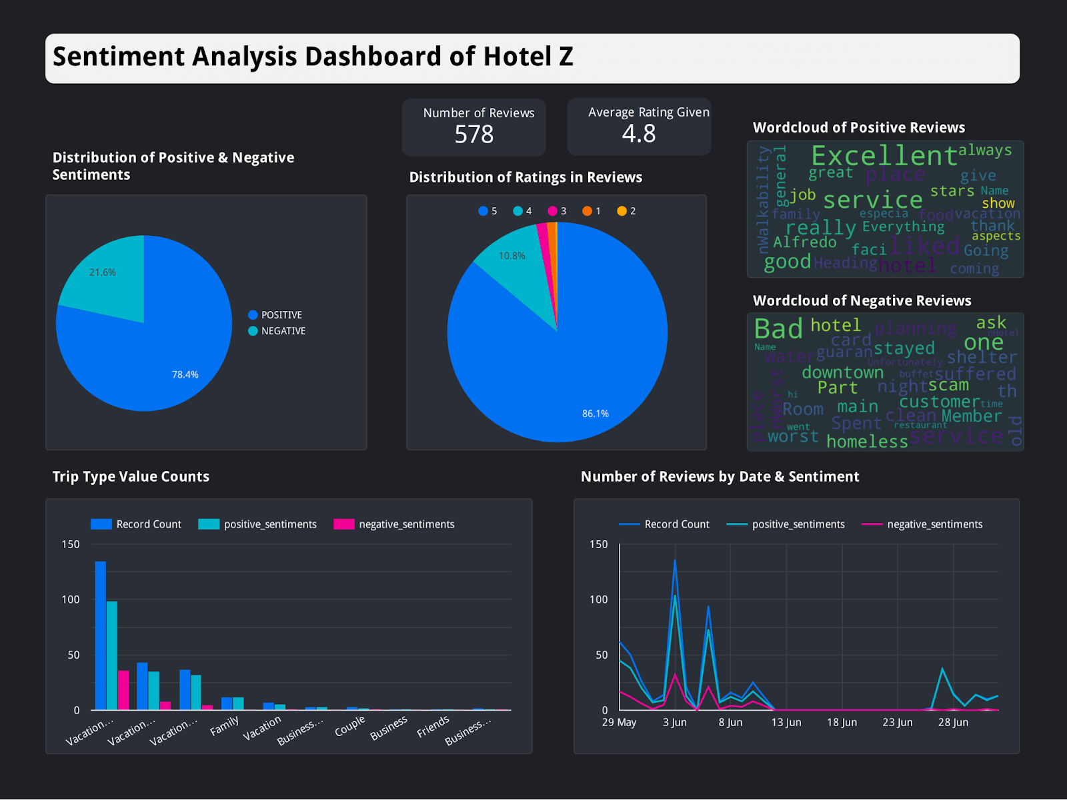

I needed a way to draw these graphs in python, which I chose matplotlib for. It’s the most popular visualization library in python. (Talaj, 2024).

With a basic implementation of the pie chart added into the program:

I decided to split up my classes:



Initially I tried to import the data file of dashboard into piechart, but this gave a circular dependency because piechart was being used in dashboard. So I created a data script to resolve this dependency, now every file that uses data will grab from the data file.

After this I created a new class for showing totals, like in the reference image. With some simple code I managed to get some a very simple layout:

import col

import data

import streamlit as st

num_positive = data.df[col.POSITIVE_REVIEW].shape[0]

num_negative = data.df[col.NEGATIVE_REVIEW].shape[0]

total_reviews = data.df.shape[0]

average_rating = data.df[col.REVIEWER_SCORE].mean()

def draw():

    st.markdown(

    f'<p>Number of Reviews</p><h1>{total_reviews}</h1>',

    unsafe_allow_html=True

    )

    st.markdown(

    f'<p>Average Rating Given</p><h1>{average_rating:.2f}</h1>',

    unsafe_allow_html=True

    )

This however didn’t look very good so I decided to use the build in columns feature of streamlit (Streamlit, 2024):

def draw():

    col1, col2 = st.columns(2)

    with col1:

        st.markdown(

        f'<p>Number of Reviews</p><h1>{total_reviews}</h1>',

        unsafe_allow_html=True

        )

    with col2:

        st.markdown(

        f'<p>Average Rating Given</p><h1>{average_rating:.2f}</h1>',

        unsafe_allow_html=True

        )

Which already gave it a much cleaner design, and more clear too. However it could still use a bit of polish to stand apart, just like in the refence image. To do this, I use some simple CSS to define a box (Mmdn web docs, 2024) around my text:

import col

import data

import streamlit as st

num_positive = data.df[col.POSITIVE_REVIEW].shape[0]

num_negative = data.df[col.NEGATIVE_REVIEW].shape[0]

total_reviews = data.df.shape[0]

average_rating = data.df[col.REVIEWER_SCORE].mean()

def draw():

    st.html("""

    <style>

    .metric-box {

        background-color: #1e1e1e;

        color: white;

        padding: 10px;

        border-radius: 8px;

        text-align: center;

        box-shadow: 0px 2px 4px rgba(0, 0, 0, 0.2);

    }

    .metric-box h1 {

        margin: 0;

        font-size: 2em;

    }

    .metric-box p {

        margin: 0;

        font-size: 1.2em;

        font-weight: bold;

    }

    </style>

    """)

    col1, col2 = st.columns(2)

    with col1:

        st.html(f'<div class="metric-box"><p>Number of Reviews</p><h1>{total_reviews}</h1></div>')

    with col2:

        st.html(f'<div class="metric-box"><p>Average Rating Given</p><h1>{average_rating:.2f}</h1></div>')

After this I continued to work on the piechart class, because I wanted another piechart, just like the reference image, because having an overall score distribution on the dashboard presented as a piechart is a good metric for the user to see. I did this by first renaming the draw function in the class to the specific pie it draws, so draw_positive_negative, and then for the new piechart, gave it the name draw_score_distribution, so that both could be called in the dashboard.py class like so:

piechart.draw_positive_negative()

piechart.draw_score_distribution()

Other than this, the piechart makes use of histogram math (the graphs that are usually displayed as bars), to section it in each pie. Notably, every pie has been normalized to fit into 1 through 5, since the actual review score is from 1 to 10. (So 1 is 1-2, 2 is 3-4 and so on).

For some playful visualization, I also decided to add a wordcloud, like the reference image. Just like the reference image I separated it into two separate wordclouds for negative and positive words. I used an article about wordcloud as reference, despite really liking the masks applied within the article, I don’t think it would be beneficial to add it to the dashboard, so I did not use that step. (Wang, 2022). There’s also some funkiness when it comes to the drawing of streamlit, which makes use of matplotlib, by doing this it will by default give my wordcloud a white background, as denoted in a source found (Mueller, 2020). After fixing the transparency issue, the wordcloud came out clean, looking like this:

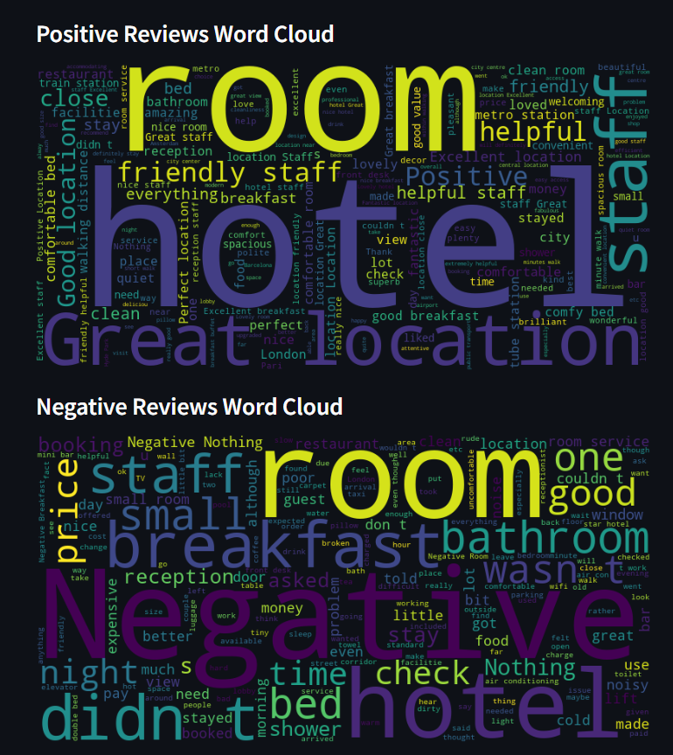

The Naive Bayes classifier is a probabilistic model based on Bayes' theorem, which is particularly effective for text classification tasks due to its simplicity and speed. VADER (Valence Aware Dictionary and sEntiment Reasoner) is a lexicon and rule-based sentiment analysis tool optimized for social media text. TextBlob is a Python library that offers a simple API for common natural language processing (NLP) tasks, including sentiment analysis, which it performs using a trained Naive Bayes classifier. (Korab, 2023) (Pius, 2023) (Navlani, 2020)

# Methods

## Data Collection

The dataset was obtained from the Kaggle repository, consisting of hotel reviews categorized as positive or negative. Additional reviews were scraped from TripAdvisor to augment the dataset.

## Data Preparation

Reviews were preprocessed by removing non-textual elements and normalizing the text. (Small sample is taken in this code for increased compilation time, loading in all of the reviews works perfectly fine, it just takes long). All of the data is send to the database.



## Sentiment Analysis Implementation

VADER and TextBlob were applied to the dataset without further training, leveraging their built-in sentiment analysis capabilities. Python's NLTK library facilitated the use of VADER, while TextBlob was directly applied for sentiment evaluation. The Naive Bayes classifier was trained on the Kaggle data.

# Results

The Naive Bayes classifier achieved an accuracy of 85-90%, while VADER and TextBlob provided fast and consistent sentiment assessments across the dataset. It general the Naive Bayes classifier was the most accurate, then VADER and afterwards TextBlob.

# Conclusion and Recommendations

The comparative analysis showed that while the Naive Bayes classifier provided a high accuracy rate, rule-based models like VADER and TextBlob offer rapid sentiment assessment for large datasets and ease of use. For real-time analysis, VADER and TextBlob are recommended due to their simplicity and efficiency.

# Bibliography

Korab, P. (2023, May 14). *Fine-tuning VADER Classifier with Domain-specific Lexicons*. Opgehaald van Medium: https://pub.towardsai.net/fine-tuning-vader-classifier-with-domain-specific-lexicons-1b23f6882f2

Navlani, A. (2020, September 5). *Naive Bayes Classification using Scikit-learn*. Opgehaald van Medium: https://avinashnavlani.medium.com/naive-bayes-classification-using-scikit-learn-60bc5176f868

Pius, A. (2023, November 22). *Using Python TextBlob for Text Classification*. Opgehaald van Medium: https://medium.com/chat-gpt-now-writes-all-my-articles/using-python-textblob-for-text-classification-7953014f54e6